You are given 2 input files.

* [athlete2SportsPlayed.txt](http://www.cs.cmu.edu/~thoffman/CODING/Sports/athlete2SportsPlayed.txt) Each line is a map of athlete to all the sports that athlete played  
  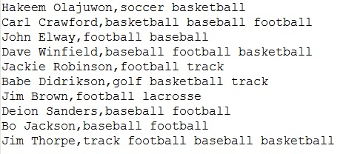
* [whoPlayedTheseSports.txt](http://www.cs.cmu.edu/~thoffman/CODING/Sports/whoPlayedTheseSports.txt) Each line of the file is a list of sports to which you must match up the athletes who played all the sports on that line.  
  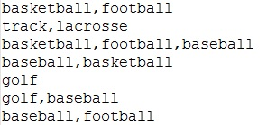
* and a code starter file: [Sports.java](http://www.cs.cmu.edu/~thoffman/CODING/Sports/Sports.java)

**EXPECTED OUTPUT: 70% for the first section, 30% for the second**

